1.Print Hello World

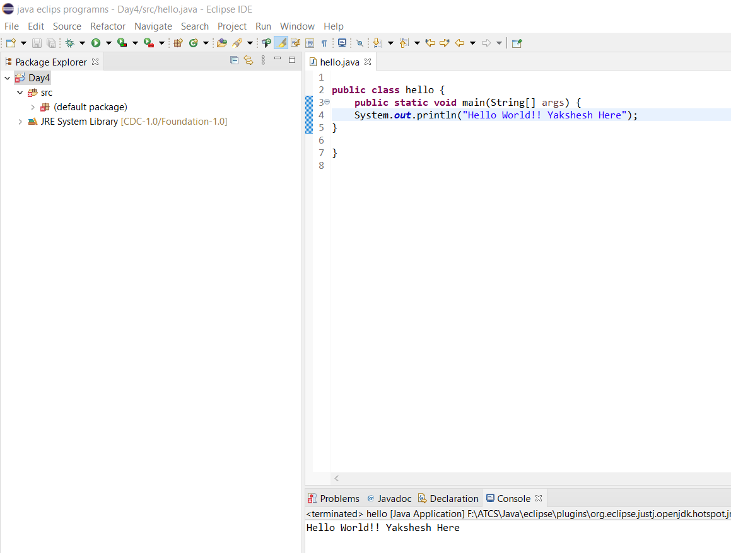

2. Add two numbers/binary numbers/characters

3.Calculate compound interest

4. Swap two Numbers

5.Calculate the area of rectangle

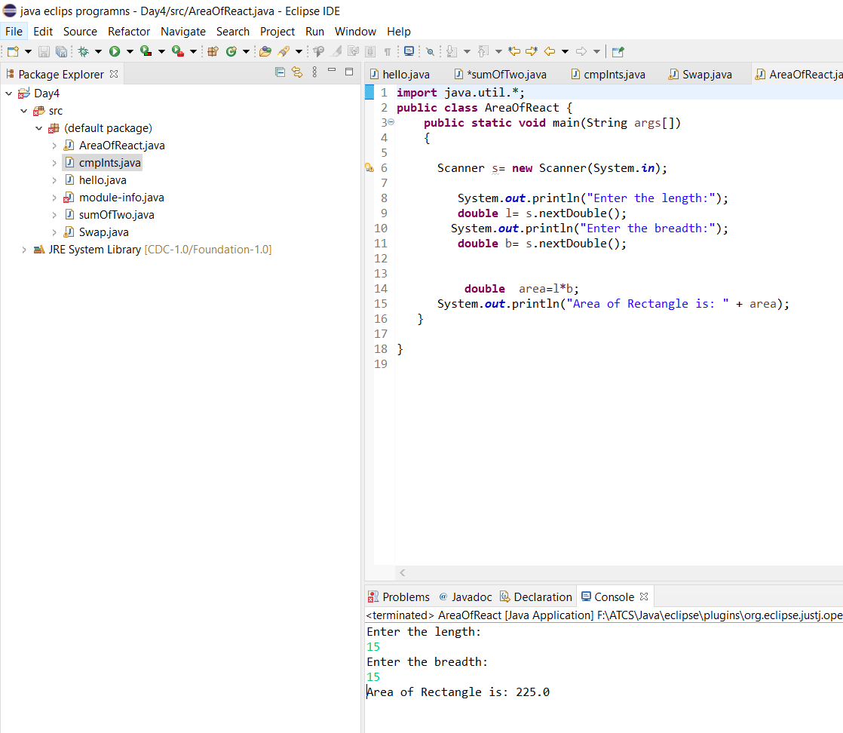

6. Calculate area and circumference of a circle using multiple classes

1. Print default values of primitive data type variable

1. Fibonacci Series

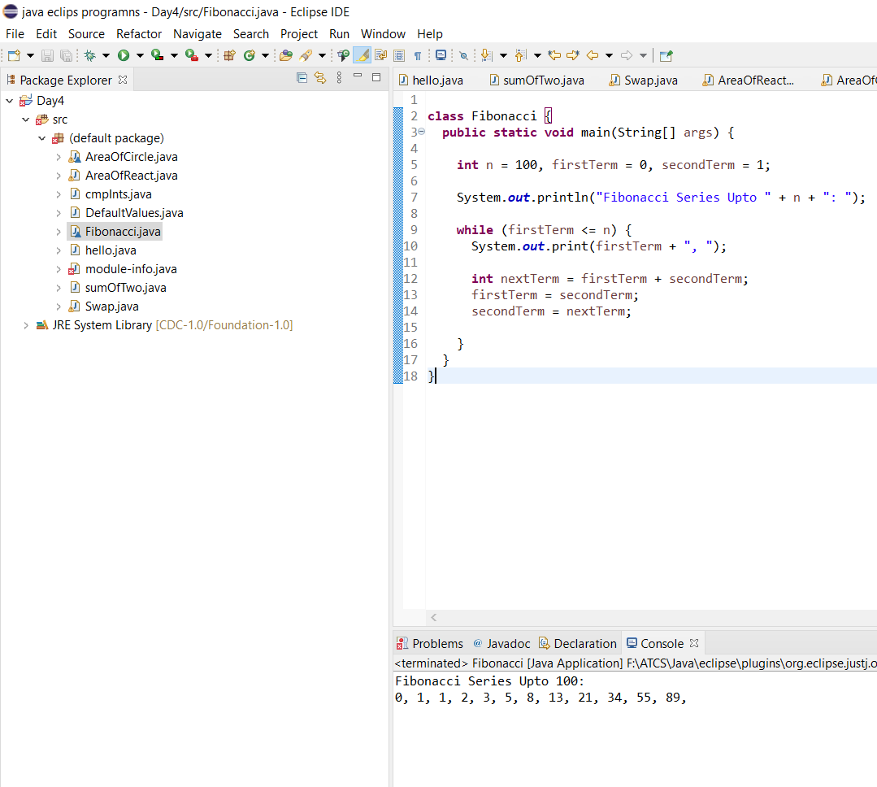

9 Ascii Values

Seesion2

1. Display prime numbers between 1 and 100 or 1 and nGraphical user interface, text, application

   Description automatically generated
2. 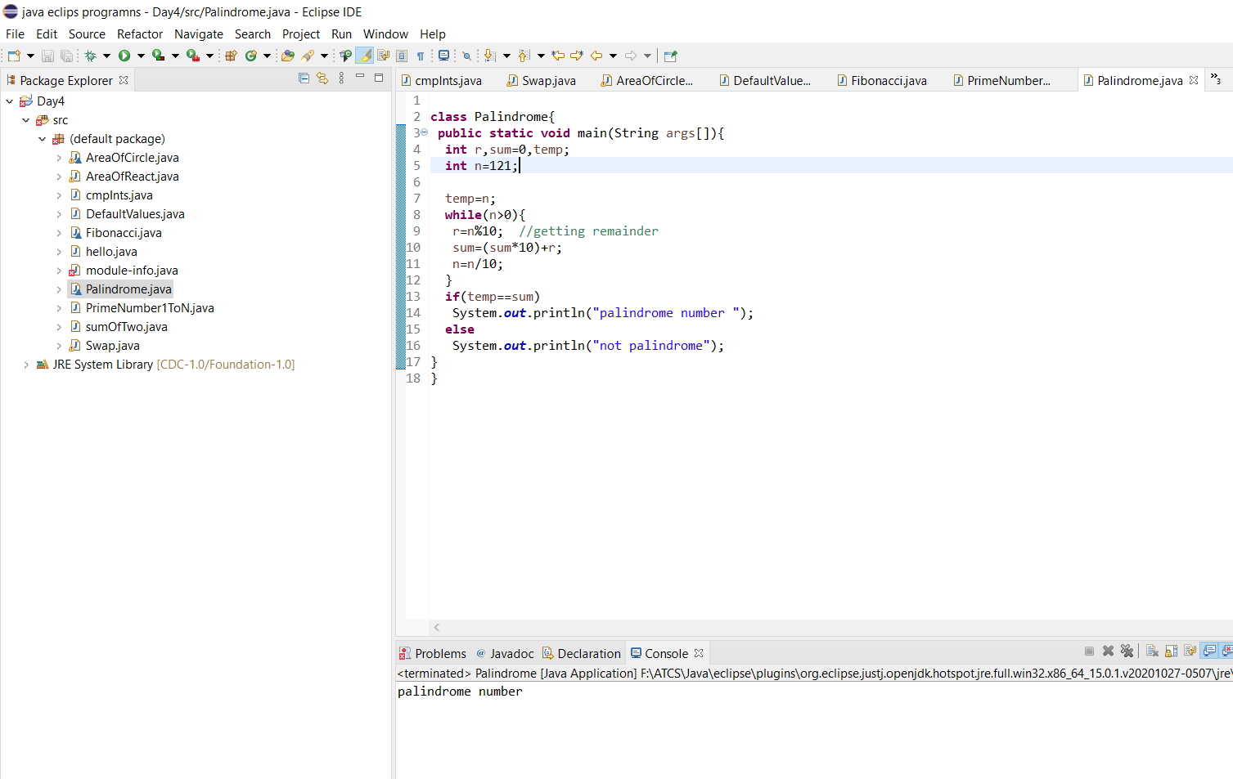Palindrome Number
3. Find the square root of a number without sqrt method

1. Determine the grades according marks percentage

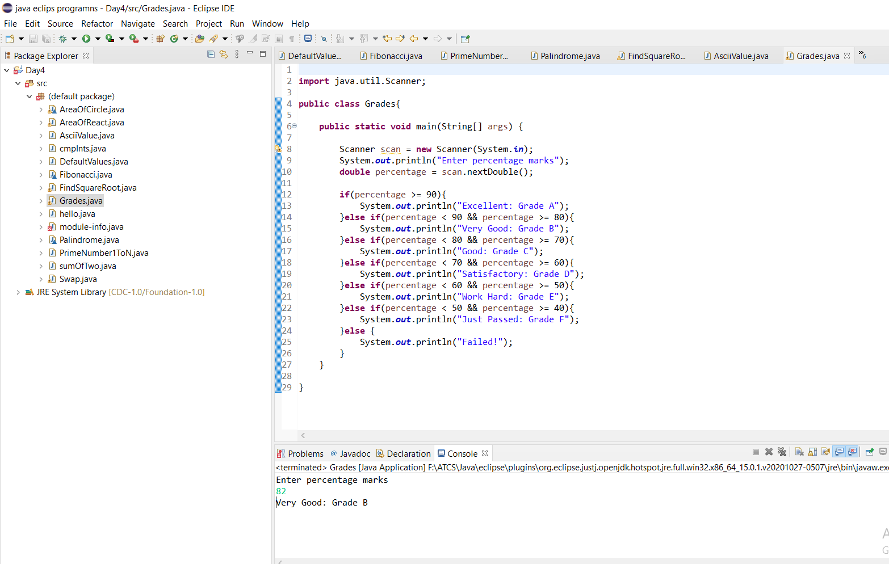

1. Use switch case, check 0 to 9 numbers.

